**DAILY ONLINE ACTIVITIES SUMMARY**

|  |  |  |  |  |  |  |  |  |
| --- | --- | --- | --- | --- | --- | --- | --- | --- |
| **Date:** | **16/07/2020** | | | | | **Name:** | **NAIPUNYA VINOD NAIK** | |
| **Sem & Sec** | **IV SEM & A SECTION** | | | | | **USN:** | **4AL18CS050** | |
| **Online Test Summary** | | | | | | | | |
| **Subject** | | **NO INTERNALS CONDUCTED** | | | | | | |
| **Max. Marks** | | **30** | | **Score** | | | **----------------** | |
| **Certification Course Summary** | | | | | | | | |
| **Course** | 1. **WEBINAR ON C PROGRAMMING** 2. **IOS ETHICAL COURSE** 3. **HARDCORE JAVA WITH ANDRIOD AND SQL APPLICATIONS** 4. **GOOGLE CLOUD PLATFORM BIG DATA AND MACHINE LEARNING FUNDAMENTALS** | | | | | | | |
| **Certificate Provider** | | | **1)AIET**  **2)UDEMY**  **3)UDEMY**  **4)COURSERA** | | **Duration** | | | 1. **2HRS** 2. **32 MIN** 3. **3 HRS** 4. **2 WEEKS** |
| **Coding Challenges** | | | | | | | | |
| **Problem Statement: Write a java program to print Pascal’s Triangle.** | | | | | | | | |
| **Status: EXECUTED** | | | | | | | | |
| **Uploaded the report in Github** | | | | | **YES** | | | |
| **If yes Repository name** | | | | | <https://github.com/naipunya-naik/Online-Coding-platformcoding/blob/master/pascal%20triangle_16-07-2020.java> | | | |
| **Uploaded the report in slack** | | | | | **YES** | | | |

Online Test Details: (Attach the snapshot and briefly write the report for the same).

NO INTERNALS CONDUCTED

Certification Course Details: (Attach the snapshot and briefly write the report for the same).

1. WEBINAR ON C PROGRAMMING

THE BELOW SNAPSHOTS ARE THE SNAPSHOTS OF WEBINAR OF C PROGRAMMING.

CONDUCTED BY:- MS. MEGHA.D.HEGDE,ASST.PROF, AIET

SUBJECT:- WEBINAR ON C PROGRAMMING

TOPICS COVERED TODAY:-

* HOW TO DO CODING?
* PLACEMENT PREPARATION TIPS
* C SCOPE VARIABLES
* CALL BY REFERENCE
* DURATION:- 2 HRS
* FROM 11 AM TO 1PM

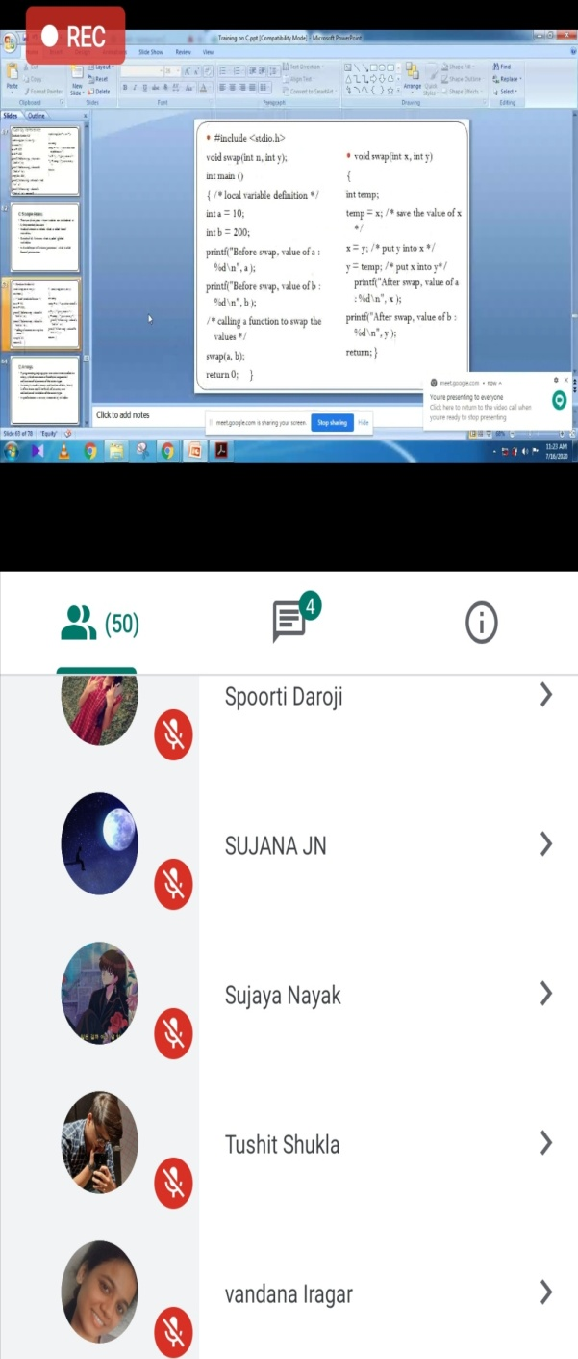 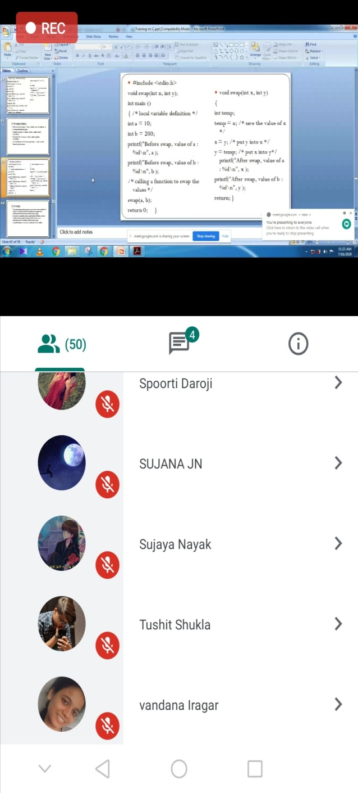

1. CERTIFICATION COURSE NAME:- **IOS ETHICAL COURSE**

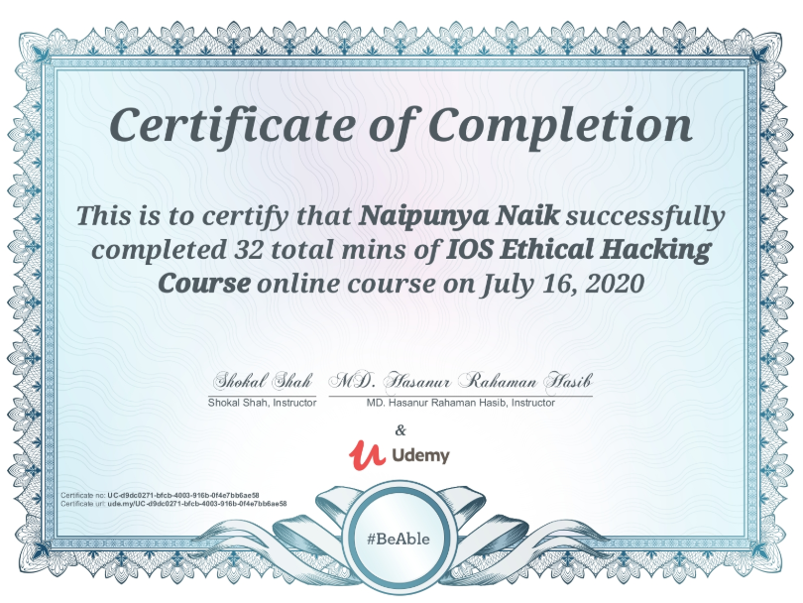

1. CERTIFICATION COURSE NAME:- HARDCORE JAVA WITH ANDROID AND SQL APPLICATIONS

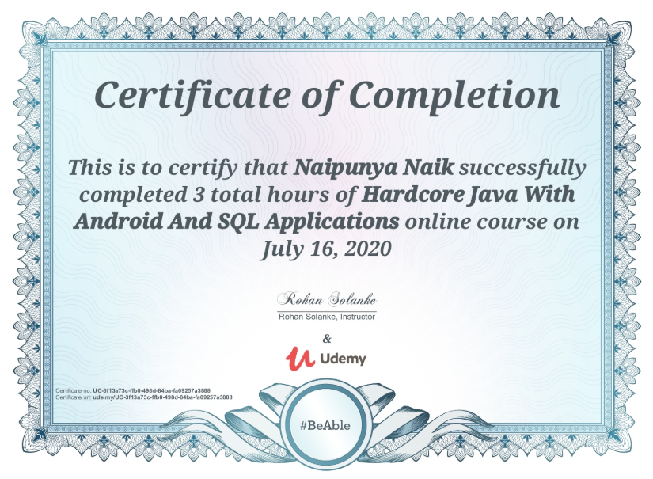

1. CERTIFICATION COURSE NAME:- **GOOGLE CLOUD PLATFORM BIG DATA AND MACHINE LEARNING FUNDAMENTALS**

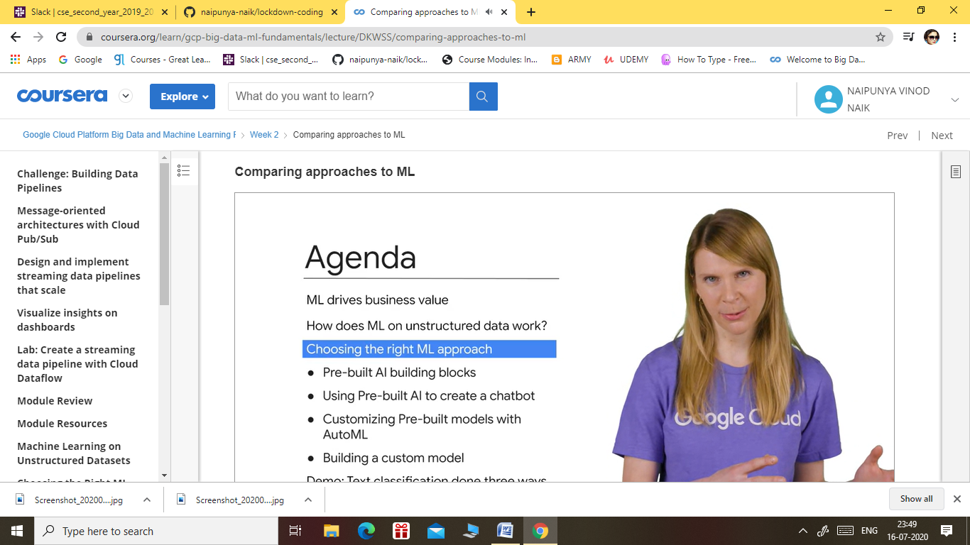

Coding Challenges Details: (Attach the snapshot and briefly write the report for the same).

PROBLEM STATEMENT:- WRITE A JAVA PROGRAM TO PRINT PASCAL TRIANGLE

TODAY, I ATTEMPTED A QUESTION FROM GEEKS FOR GEEKS WEBSITE TO PRINT THE PASCAL TRIANGLE.

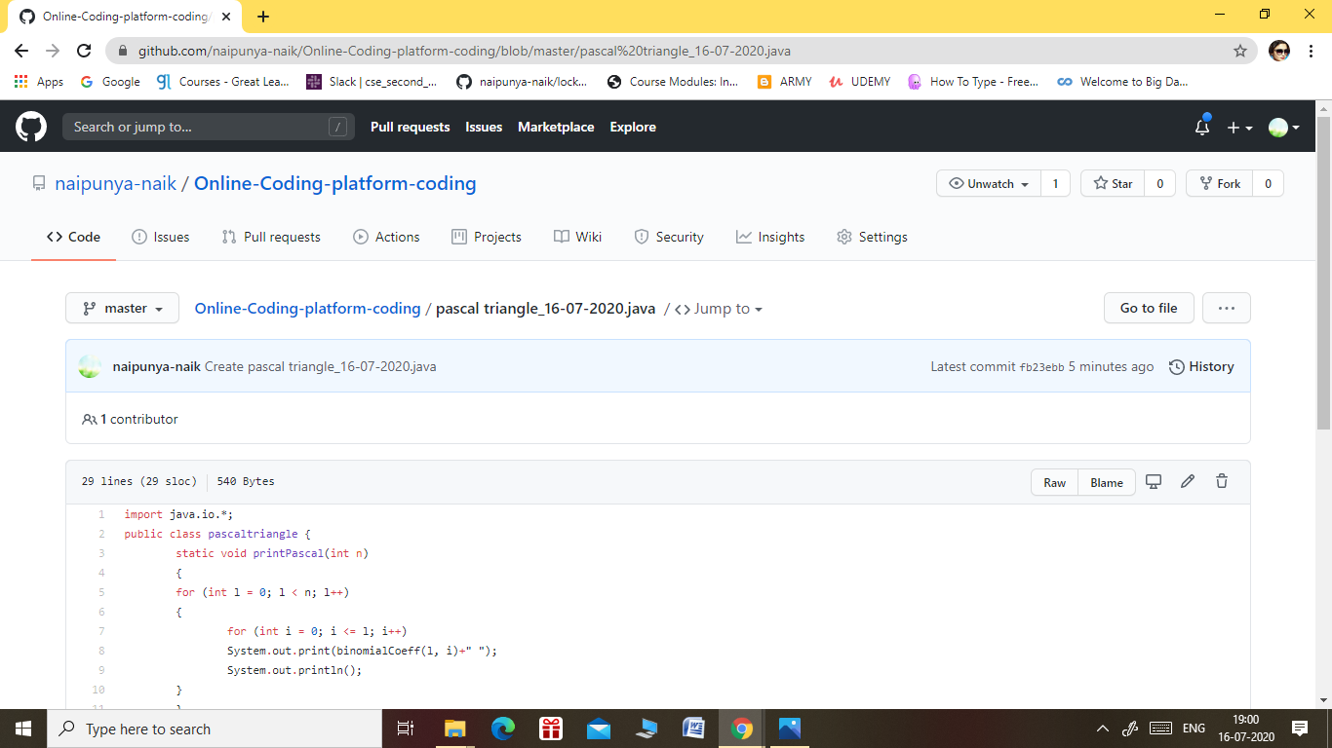

GITHUB REPOSITORY LINK:-

<https://github.com/naipunya-naik/Online-Coding-platform-coding/blob/master/pascal%20triangle_16-07-2020.java>